## VALE MEDICAL GROUP NEWSLETTER

## January 2025

**VALE MEDICAL GROUP**

**Stackyard Surgery**

**Tel: 01476 870900**

**Email – llricb-llr.stackyard.admin@nhs.net**

**Long Clawson Medical Practice**

**Tel: 01664 822214**

**Email – lcmp.admin@nhs.net**

……………………………………………………..……………………………………………………..……………………………………………………..……………………………………………………..……………………………………………………..……………………………………………………..……………………………………………………..……………………………………………………..…………………………………………………….. …………………………………………………….. ……………………………………………………..……………………………………………………..

**Dry January**  
  
If you’re thinking about a month without alcohol but aren’t sure what to expect, then read on! Over the first few weeks, you’ll find your energy levels increase, you sleep better, your memory improves and you may lose weight.  
  
To help keep you on track throughout the month with support, encouragement and goal setting, Dry January has introduced a new app this year, available free on the website.  
  
<https://alcoholchange.org.uk/blog/benefits-of-dry-january-and-when-you-can-expect-to-see-them>



**Love Your Liver Month**  
  
Did you know that 90% of liver disease is preventable? Taking steps towards a healthier lifestyle can help to avoid damage to your liver.  
  
The liver is the largest organ in the body, performs hundreds of functions, and has the incredible ability to regenerate, but it’s really important to prevent damage that can become irreversible.  
  
Show your liver some love by making a pledge to do something healthy this January.  
  
<https://britishlivertrust.org.uk/love-your-liver-month/>

**Happy New Year**

**New year, new challenges  
Thinking of changing your lifestyle for the new year?**

**Whether you’re trying to exercise more, improve your diet or give up a habit, support can make the difference between success and lapsing into old ways. Choose from the below links or ask to speak to one of our nurses at the surgery.**

[**https://www.nhs.uk/better-health/quit-smoking/**](https://www.nhs.uk/better-health/quit-smoking/)[**https://www.nhs.uk/better-health/get-active/**](https://www.nhs.uk/better-health/get-active/)[**https://www.nhs.uk/better-health/lose-weight/**](https://www.nhs.uk/better-health/lose-weight/)

**DNAs (Did not attend)**

DNA is someone who did not attend their doctor/nurse appointment and did not tell us beforehand.  
The clinic was ready, the doctor and nurses were waiting, but the patient did not attend. Last month in December there were **115 DNAs** at the Long Clawson Medical Practice and at the Stackyard Surgery, which patients did not attend.

If you are unable to attend your appointment, please let us now as Soon as you can so we can arrange for someone else to take your appointment.

**Friends and Family**

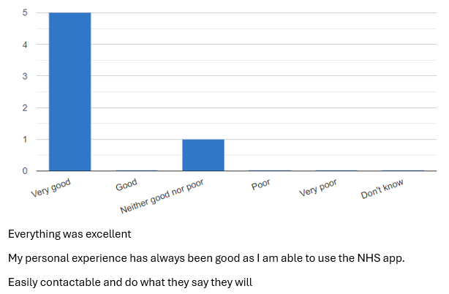

**Cervical Cancer Awareness Week, 22nd – 28th January**

It’s important to attend your cervical screening when you receive your invitation. This test checks for a virus called human papillomavirus (HPV) and catching this early can help reduce the risk of cervical cancer developing.

Cervical screening is free for anyone with a cervix, between the ages of 25-64. It’s not a test for cancer, but detects a virus called human papillomavirus (HPV). High-risk HPV may cause cellular changes which could develop into cancer over time, although not all cell changes will cause cancer. Regular screening is essential to catch any changes quickly.  
  
Some people can be anxious about having a cervical screening test. It can be helpful to know what to expect when you come for your appointment. Book with our nurse.   
<https://www.cancerresearchuk.org/about-cancer/cervical-cancer/getting-diagnosed/screening/about>  
[https://www.cancerresearchuk.org/about-cancer/cervical-cancer/getting-diagnosed/screening](https://www.cancerresearchuk.org/about-cancer/cervical-cancer/getting-diagnosed/screening/about)

**National Obesity Awareness Week, 10th – 16th January**  
Losing weight can be a struggle, but setting small goals can help you achieve and maintain your goals in the long term.  
Here are some useful tips to help keep you on track:

* Get active every day
* Aim to eat five portions of fruit and vegetables daily
* Cut down on sugar, fat and salt
* Read the coding on food labels – opt for green rather than red!

Book an appointment with our weight-loss team today via our online form/phone or download the free NHS plan here:

<https://www.nhs.uk/better-health/lose-weight/>

**Cold weather challenges**

Prolonged exposure to cold temperatures can cause long-term health problems for vulnerable people. There’s a higher risk of stroke, respiratory infection and falls, alongside the mental health impacts of being in a cold home.Warm Welcome Spaces are inclusive, heated, offer hot drinks and are free to visit. Not only are they warm, friendly places to visit, but they’re great places to meet new people. Find your local Warm Spacehere:

<https://www.warmwelcome.uk/find-a-space>

**Pharmacy First**

You don’t always need to wait to see a GP for some common minor conditions. Pharmacies can offer advice and guidance for conditions that don’t require a prescription, and many pharmacies have specially trained Pharmacists who are now able to diagnose and treat a number of minor illnesses.  
<https://www.nhs.uk/nhs-services/pharmacies/how-pharmacies-can-help>

**Patient participation groups are generally made up of a group of volunteer patients, the practice manager and one or more of the GPs from the practice. PPG meetings are held on a regular basis to discuss the services on offer, and how improvements can be made from the benefits of patients and the practice.**

**The VMG PPG currently has over 15 members and have meetings every three months, and our chair is Martin Fagan.**

**If you wish to make contact, please email** [**info@valeppg.uk**](mailto:info@valeppg.uk)

…………………………………………………………………………… Vale Medical Group … ………………….

………………………………………………………