## VALE MEDICAL GROUP NEWSLETTER

## March 2025

**VALE MEDICAL GROUP**

**Stackyard Surgery**

**Tel: 01476 870900**

**Email – llricb-llr.stackyard.admin@nhs.net**

**Long Clawson Medical Practice**

**Tel: 01664 822214**

**Email – lcmp.admin@nhs.net**

……………………………………………………..……………………………………………………..……………………………………………………..……………………………………………………..……………………………………………………..……………………………………………………..……………………………………………………..……………………………………………………..…………………………………………………….. …………………………………………………….. ……………………………………………………..……………………………………………………..

**Friends and Family**

**www.valemedicalgroup.co.uk/about-us/friends-and-family-test**

**DNAs (Did not attend)**

DNA is someone who did not attend their doctor/nurse appointment and did not tell us beforehand.  
The clinic was ready, the doctor and nurses were waiting, but the patient did not attend. Last month in January there were **95 DNAs** at the Long Clawson Medical Practice and at the Stackyard Surgery, which patients did not attend.

If you are unable to attend your appointment, please let us now as Soon as you can so we can arrange for someone else to take your appointment.

***Find your NHS Number***  
  
Need to know your NHS number but can’t remember where you wrote it down? Don’t worry! Find it here:  
  
<https://www.nhs.uk/nhs-services/online-services/find-nhs-number/>

**Breast screening**  
  
Had an invite for breast screening? Make sure you mark the date in your diary!  
  
Breast screening uses a test called mammography which involves taking X-rays of the breasts. Screening can help to find breast cancers early and these cancers are usually easier to treat than larger ones.  
  
It’s important to remember that screening won’t prevent you from getting breast cancer but it aims to find early breast cancers.  
  
Regular breast screening is one of the best ways to spot a cancer that’s too small to feel or see yourself. It saves around 1,300 lives each year in the UK!  
  
Don’t ignore your invite when it lands on your doorstep!

[www.nhs.uk/conditions/breast-screening-mammogram/](http://www.nhs.uk/conditions/breast-screening-mammogram/)

[https://campaignresources.dhsc.gov....help-you-cancer/breast-screening-saves-lives/](https://campaignresources.dhsc.gov.uk/campaigns/help-us-help-you-cancer/breast-screening-saves-lives/)

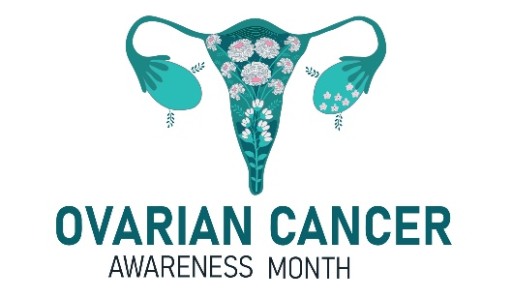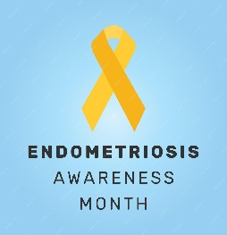

**Ovarian Cancer Awareness Month, 1st–31st March**  
Feeling bloated? Need to wee more? Feeling full? Unexplained tummy pain? Raising awareness of ovarian cancer is vital in improving early diagnosis. Currently, just one in five women can name bloating as a symptom of ovarian cancer.  
  
Ovarian Cancer Awareness Month highlights the importance of picking up on early changes. Two-thirds of women are diagnosed with ovarian cancer too late, when the cancer is harder to treat. We need to change that! If you have any of these ongoing symptoms, make an appointment with your GP.

**World Kidney Day 13th March**

World Kidney Day is an annual campaign to help raise awareness of kidneys and what can happen when they don’t work properly. Chronic kidney disease (CKD) is estimated to affect approximately 850 million people worldwide and by detecting changes early, there is a greater chance of finding a successful treatment.  
It’s very common for early kidney disease to show no symptoms. Only as it progresses will you start to see changes such as increased urination, swollen feet and hands, and general fatigue.  
If you take long-term medication, have diabetes, or CKD runs in your family, it’s important to keep an eye on your kidney health.  
#AreYourKidneysOK #WorldKidneyDay  
<https://www.worldkidneyday.org/2025-campaign/>

**Patient participation groups are generally made up of a group of volunteer patients, the practice manager and one or more of the GPs from the practice. PPG meetings are held on a regular basis to discuss the services on offer, and how improvements can be made from the benefits of patients and the practice.**

**The VMG PPG currently has over 15 members and have meetings every three months, and our chair is Martin Fagan.**

**If you wish to make contact, please email** [**info@valeppg.uk**](mailto:info@valeppg.uk)

**Endometriosis Awareness Month, 1st–31st March**

Endometriosis occurs when cells similar to the ones in the lining of the womb (uterus) are found elsewhere in the body. It can have a significant impact on the sufferer’s life from pain and anxiety to infertility and debilitating fatigue. Support and diagnosis are key to improving quality of life

For Endometriosis Action Month 2025, the theme is ‘endometriosis explained’. It’s vital that endometriosis is better understood by the general public and better explained to patients by healthcare practitioners. In the UK, endometriosis affects one in ten women and those assigned female at birth, yet so many are still unaware of the condition and its impact.⁠  
Find out more here:  
<https://www.endometriosis-uk.org/what-is-endometriosis>

**Young Carers Action Day, 13th March**

Are you, or is someone you know, a young carer?  
Young carers action day is celebrated every year, shining a spotlight on the invaluable contributions and challenges faced by young carers. This year’s theme is ‘give me a break’, focusing on the importance of rest and respite for young carers. We also call on schools and employers to provide better support, helping carers to balance their responsibilities and achieve their full potential.  
  
Young carers face a huge array of challenges because of their caring role. Many are disadvantaged across multiple aspects of their lives, including mental and physical health, finances, education and employment.  
[Https://carers.org/getting-support-...if-you-are-a-young-carer-or-young-adult-carer](https://carers.org/getting-support-if-you-are-a-young-carer-or-young-adult-carer/getting-support-if-you-are-a-young-carer-or-young-adult-carer)

…………………………………………………………………………… Vale Medical Group … ………………….

………………………………………………………